**Summarization of placement Dataset:**

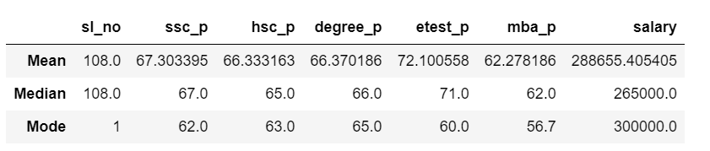

**Mean:**

Mean is often called the average. Useful for understanding the general trend of a dataset, but it can be influenced by outliers.

ssc_p – average marks (67.303395)

hsc_p – average marks (66.333163)

degree_p – average marks (66.370186)

etest_p – average marks (72.100558)

mba_p – average marks (62.278186)

salary – average salary (288655.405405)

**Median:**

The **median** is the middle value in a dataset when the numbers are arranged in order (either ascending or descending) and is especially useful because it’s not affected by extreme values (outliers) as much as the mean.

ssc_p – average marks (67.0)

hsc_p – average marks (65.0)

degree_p – average marks (66.0)

etest_p – average marks (71.0)

mba_p – average marks (62.0)

salary – average salary (265000.0)

**Mode:**

The **mode** is the value that appears most frequently in a dataset that shows the most common values in the data. Unlike the mean and median, a dataset can have more than one mode or no mode at all.

ssc_p – repeated marks (62.0)

hsc_p – repeated marks (63.0)

degree_p – repeated marks (65.0)

etest_p – repeated marks (60.0)

mba_p – repeated marks (56.0)

salary – repeated salary (300000.0)